Ryan Garner

Quick Mix Requirements and Design

Requirements:

1. Site must be able to search for different drink recipes depending on the liquor that the user chooses.
2. Just about every liquor must be represented in the sense that no matter what liquors are chosen, search result will come up.
3. Users will be able to choose what kind of flavor they would like their drink to have if they choose to do so (Eg: Fruity, Savory, sweet, sour, etc…).
4. Users will be able to favorite which drinks they like and will be kept track in their profile.
5. Recipes on the site will be simple and easy to make
6. If users chose multiple liquors that they want to use, not only will drinks containing the separate liquors be displayed, but also drink that contain 2 or more of the drinks chosen
7. Users will be able to share the link to recipes that they want to send to other people

Design:

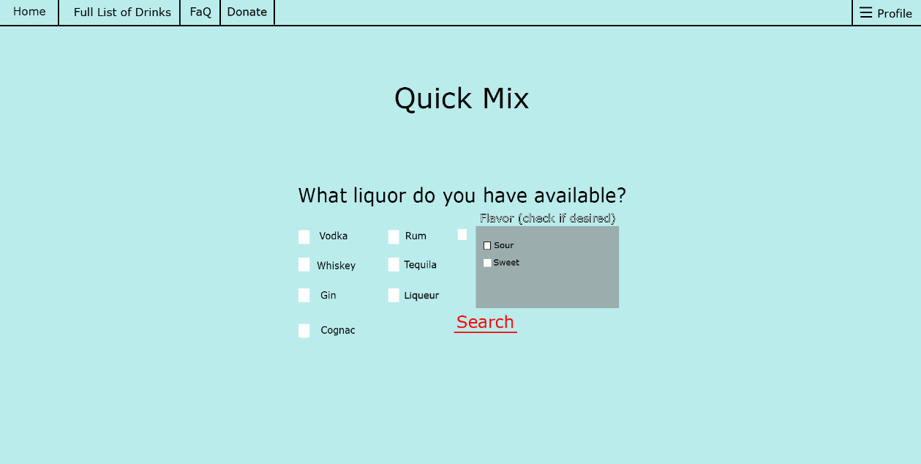Home Screen:

The home screen is going to be a pretty simple interface, it will take you right to the main function of the site. On the top there are tabs to take you back to the home screen, a tab that will show the full list of drinks with no real specifications, a FaQ section with questions and answers about the site and how it works, a donation section, and then a tab to access your profile. Right from the start, you will be able to choose whichever liquors that you have available to you and to the right there’s a greyed out box that will “Un-grey” once clicked which indicates that you are also searching for a certain flavor, this will cause drinks to pop up that are specified with that flavor only.

Search Results: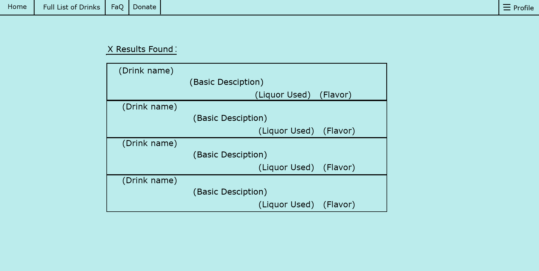

The search result screen will list the drink recipes that have meet the user’s specifications and will show how many different recipes have been found. The results will show the drink name, basic description of drink, the liquor(s) used and the flavor.

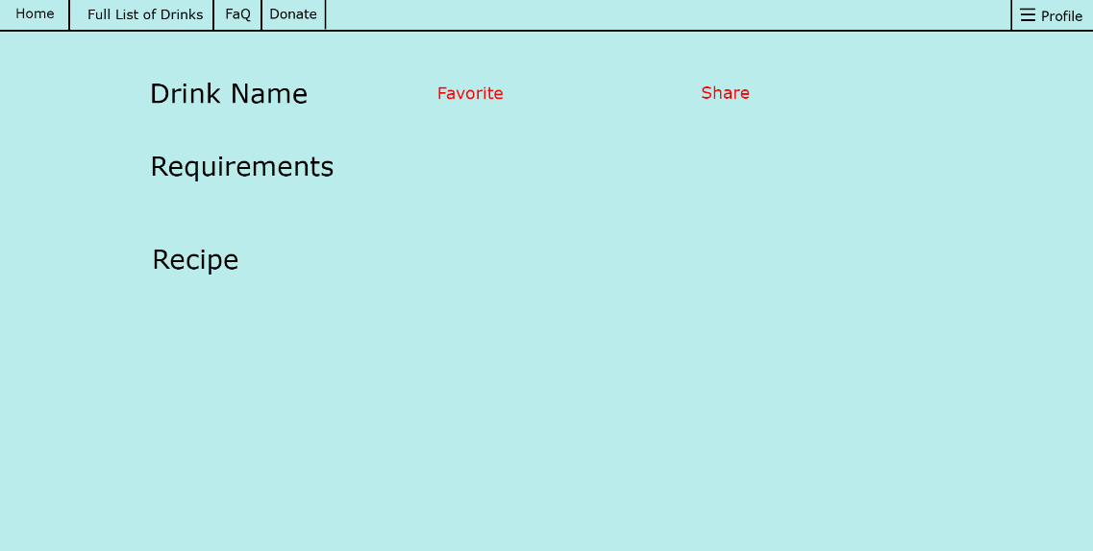Selected Drink:

This page displays the drink name, what required to make the drink, and then the recipe to make the drink. You will be able you favorite the selected drink. There will also be a share button that will copy the link to the clipboard of the user.

Profile Page: 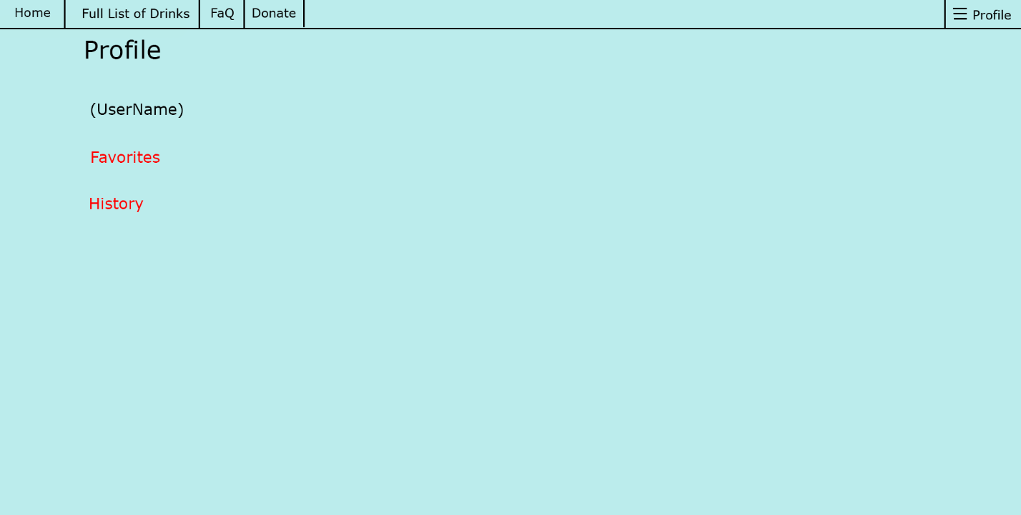

The profile page will display the username of the user, their favorite drinks, and their history of selected drinks